**Gerakan Seni Rupa Baru**

Gerakan Seni Rupa Baru (GSRB –New Art Movement) was an art movement that emerged in Indonesia in the mid-1970s. It is commonly accepted that the first signs of contemporary art in Indonesia emerged predominantly due to the actions of this movement. GSRB was established during a period when younger artists had become dissatisfied with the lack of social and political consciousness in art, coupled with the perceived arrogance of power endemic at institutional and state levels in Indonesia. The movement from the mid-1970s instigated new contemporary art discourse and re-defined art making in Indonesia. GSRB continued to gain momentum in the latter half of the 1970s: the movement involved an increasing number of artists, from 1975 to 1979 and in the mid-1980s exhibitions were organised in various Indonesian cities, and in 1978 a publication issued. Prominent members included Jim Supangkat, FX Harsono, Dede Eri Supria, Nyoman Nuarta, S. Prinka, Wagiono Sunarto and Bachtiar Zailoel. These artists experimented with found objects, installation and ready-mades, and largely addressing conceptual approaches in their making. GSBR had begun to articulate a new path for practice and its spirit of experimentation and opposition inspired and influenced, and laid a foundation for the next generation of artists.

Among the catalysts for GSRB’s formation was a pivotal incident now known as ‘Black December’. In 1974, when the jurors at a major Jakarta Arts Council exhibition presented the exhibition’s awards exclusively to decorative and abstract artists, who were all art academy lecturers, there was an outpouring of discontent from these young artists. The Black December manifesto followed, including vehement advocations for plurality and inclusivity in artistic expression. Gaining impetus from such events, GSRB formed shortly after, and through collective frustration and aspiration united what had historically been divergent student camps in Bandung and Yogyakarta, the two leading art academies.

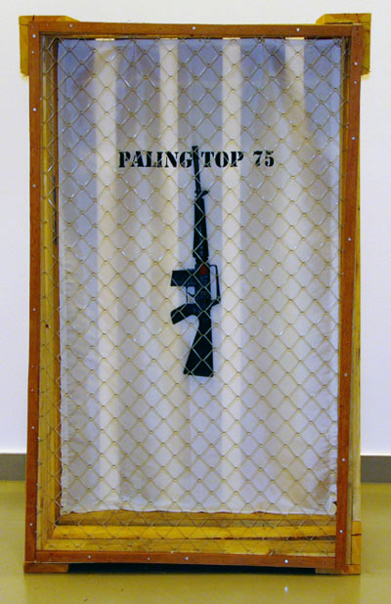

FX Harsono, *Paling Top ’75 (The most top ’75)*, 1975, mixed media (gun, crate, paint), 156.7 x 99.5 x 50 cm, collection of National Heritage Board, Singapore.

The students’ shared ambition was to reject the concept of fine art and to search for a new art. GSRB’s first exhibition, held in Jakarta, 1975, received widespread coverage, almost all of it negative, with the work condemned by a large proportion of the local art establishment due to a lack of understanding of the conceptual process behind the works. GSRB was a revolt against the art establishment, but equally against the larger power, Suharto’s New Order regime. It fervently opposed the ideologies of the New Order, including the separation of art from the political scene and the brandishing of ‘national culture’, which took traditional, mainly Javanese, culture and traditions as its platform. The repression of the New Order region resulted in the increasing entrenchment of practice and discourse. Geometric abstraction, mystic realism and expressionism flourished, and were often explored through local cultural patterning and motifs. In the 1980s the New Order’s systematic intent to depoliticise art and expression was accompanied by an art boom in conventional work. Thus avant-garde expression suffered, experimental practices were marginalised and the GSRB became stigmatised as ‘underground’. Many of the artists involved in GSRB remain prominent figures in contemporary Indonesian art, including curator Jim Supangkat and artists FX Harsono and Dede Eri Supria.

**References and Further Reading**

Supangkat, J. (1979) *Gerakan Seni Rupa Baru Indonesia: Kumpulan Karangan*, Jakarta: Gramedia.

Supriyanto, Enin (2008) *The Contemporary and Sub-Cultures: A Slice of Indonesian Contemporary Art*, Hong Kong: Asia Art Archive (video). Available at: <http://www.aaa.org.hk/Collection/CollectionOnline/SpecialCollectionItem/4417>